# Department of Computing

# MATH 333: Numerical Analysis

# Class: BSCS-9ABC

# Lab 12: Trapezoidal Rule

# Date: May 11, 2022

# Time: 10:00 am – 1:00 pm

# Lab Engineer: Anum Asif

|  |
| --- |
| **Submitted By:**  **Fatima Seemab**  **291310**  **BSCS 9B** |

# Lab 12 : Trapezoidal Rule

**Objectives**

The purpose of this lab is to get familiar with Trapezoidal Rule.

**Tools/Software Requirement**

Matlab R2016a

**Example**

## The Trapezoidal Rule

The idea of the trapezoidal rule is to approximate a general curve by trapezoids, like this. We illustrate with the problem of integrating sin(x) from 0 to pi. Of course, the true value of the integral is 2.

ezplot('sin(x)', [0, pi]), hold on

approx = zeros(1,7); %initialize vector of results

for j = 1:7

n = 2^j;

x = pi*(0:1/n:1);

plot(x, sin(x), 'r')

weights = [1, 2*ones(1,n-1), 1];

approx(j) = pi/(2*n)*sin(x)*weights';

end

disp('Using Trapezoidal Rule')

disp(' n Approximation')

for j = 1:7

disp(['n = ', num2str(2^j, '%d'), ' ', num2str(approx(j), '%1.10f')])

*Using Trapezoidal Rule*

*n Approximation*

*n = 2 1.5707963268*

*n = 4 1.8961188979*

*n = 8 1.9742316019*

*n = 16 1.9935703438*

*n = 32 1.9983933610*

*n = 64 1.9995983886*

*n = 128 1.9998996002*

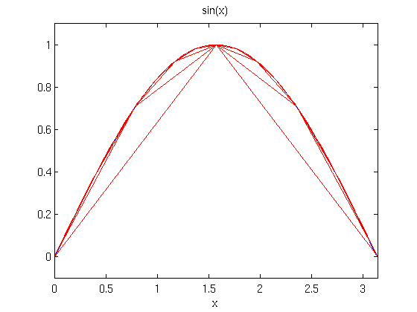

**Lab Task**

Use the trapezoidal rule to numerically integrate



From a = 0 to b = 0.8.

Also plot the Values.

**CODE:**

|  |
| --- |
| fx=[25 -120 90 2 0.2];  func=poly2sym(fx);  pi=0.8  ezplot(func, [0, pi]), hold on  approx = zeros(1,7); %initialize vector of results  for j = 1:7  n = 2^j;  x = pi*(0:1/n:1);  p=polyval(fx,x)  plot(x, p, 'r')  weights = [1, 2*ones(1,n-1), 1];  approx(j) = pi/(2*n)*p*weights';  end  disp('Using Trapezoidal Rule')  disp(' n Approximation')  for j = 1:7  disp(['n = ', num2str(2^j, '%d'), ' ', num2str(approx(j), '%1.10f')])  end |

**OUTPUT:**

Workspace

**PLOT:**

**Deliverables**

Submit single word file with matlab code and screen shot of Output.